Onwardca.org Listings Test
Objective:
Determine if the organizational entities listed on the onwardca.org website voluntarily submitted listing information to be posted or provided consent for onwardca.org to do so.
Methodology:
1. Capture dynamically-generated listing results based on zipcode=94602 for all categories of resources posted.
2. Send emails to a sample of entities listed, inquiring if permission was given or information was voluntarily submitted by the entity.
3. Attempt to post a resource or job listing using the webform provided on the site.
4. Encourage listed entities to send requests to owner of onwardca.org to remove their entities’ listings.

Metrics:
- count of listings sampled
- count of unique entities listed
- count of unique entities within 50 miles of zip code
- count of permissions granted
- count of listings posted via webform
- count of unique entities emailed
- count of unique entities emailed who responded
- count of unique entities emailed who requested deletion of listing(s)
- count of responses from website owner to each unique entity making the request
- count of unique entities whose listings are deleted (and number of listings per entity)
- avg time elapsed between deletion request and deletion validation
- count of jobs posted with businesses closed due to pandemic
- count of registered data brokers

[ The following screenshots document what personal information is collected, and for what purpose. ]

[ These first four screenshots document the process for registering for notifications when a match is found. This functionality is not the target of any test, but I have never received a notification. Is it fair to assume: if organizations did not provide permission to publish a listing on onwardca.org, no person would be notified of a match with that resource or job? ]

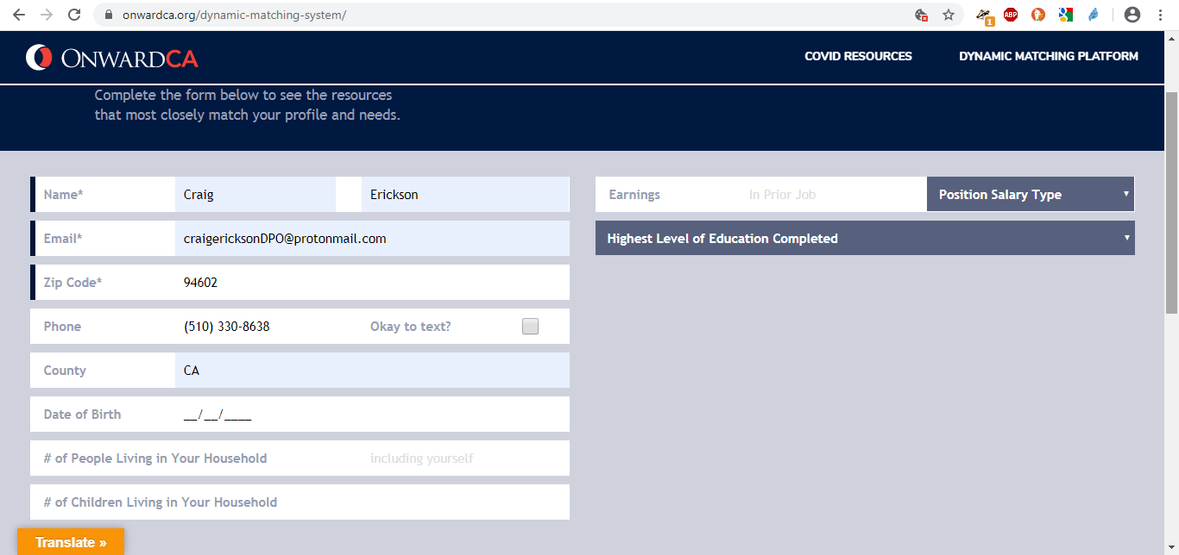
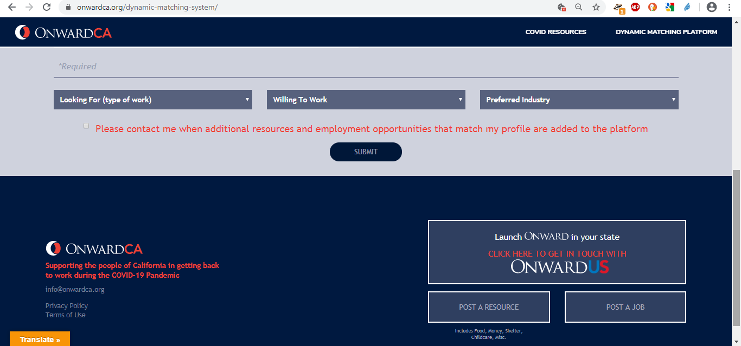
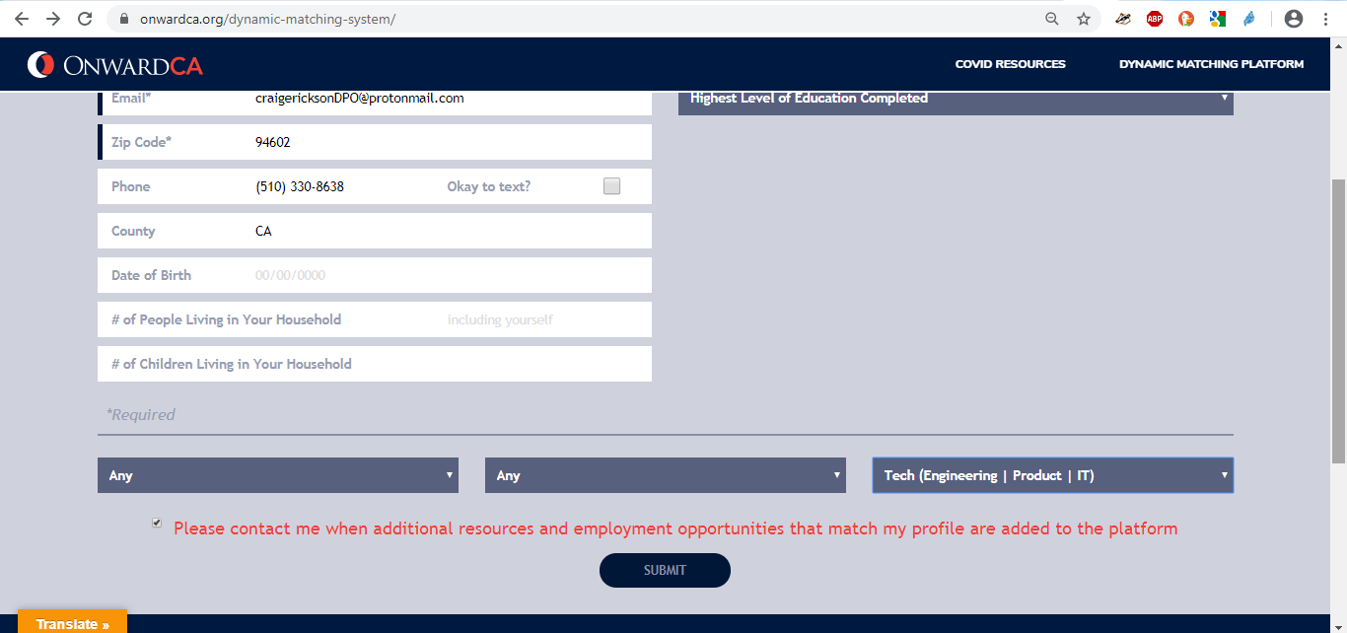

[ The above screenshot of a blank page is the result of clicking the submit button, probably due to an unhandled exception. ]

[ This next group of screenshots document the webforms used to post resources or jobs. ]
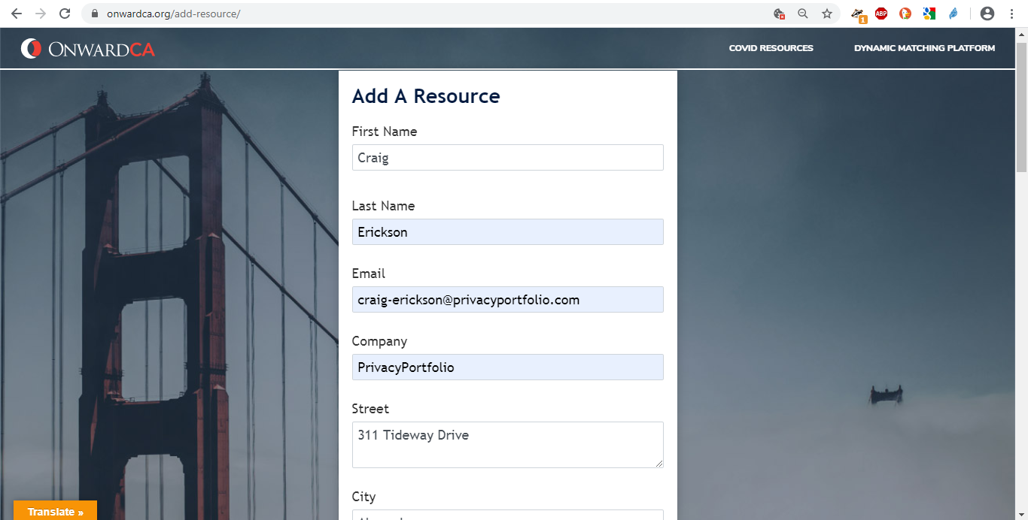
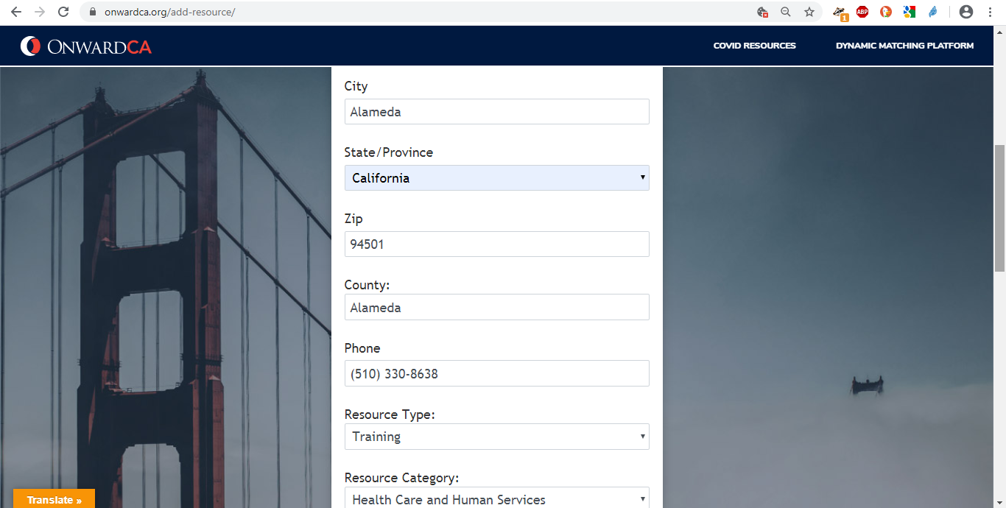
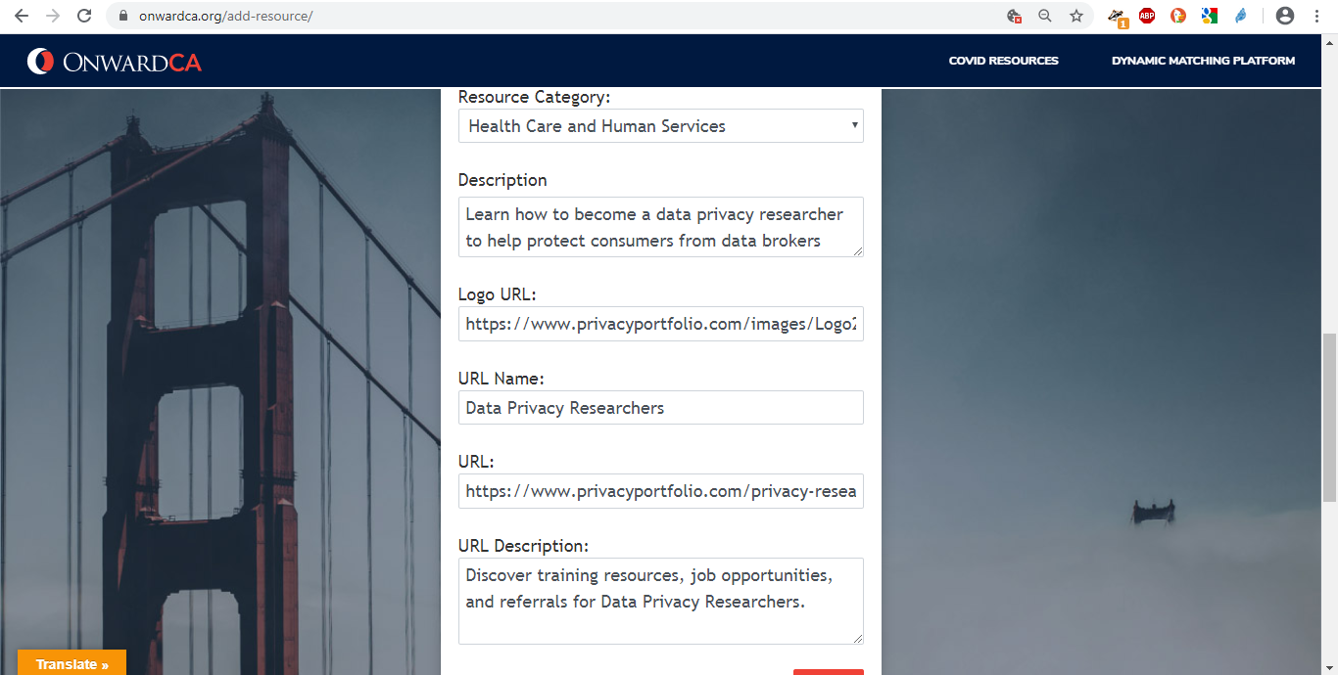
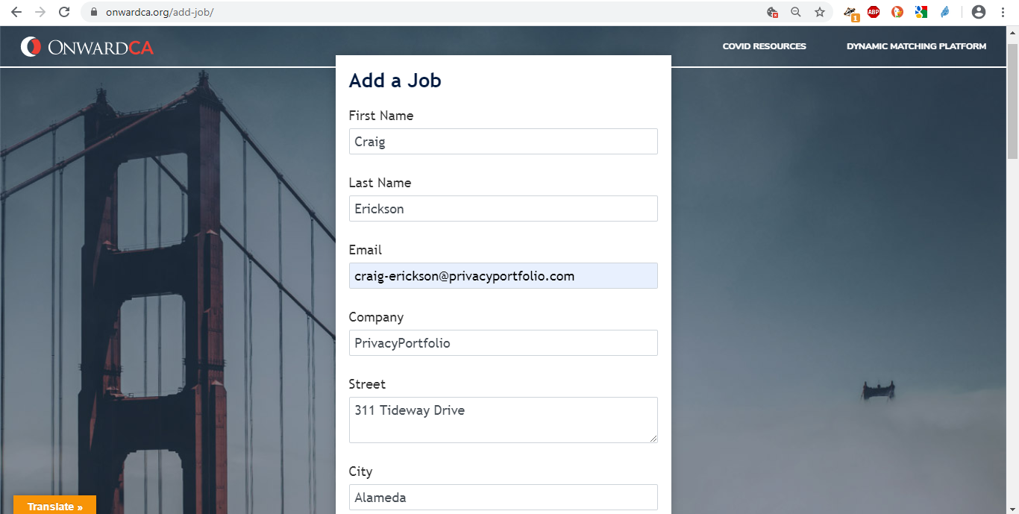
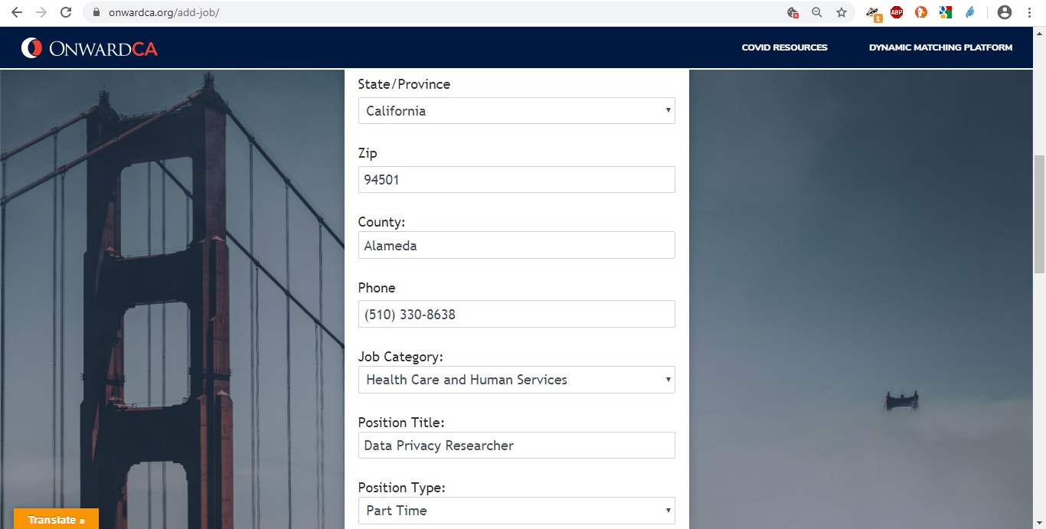
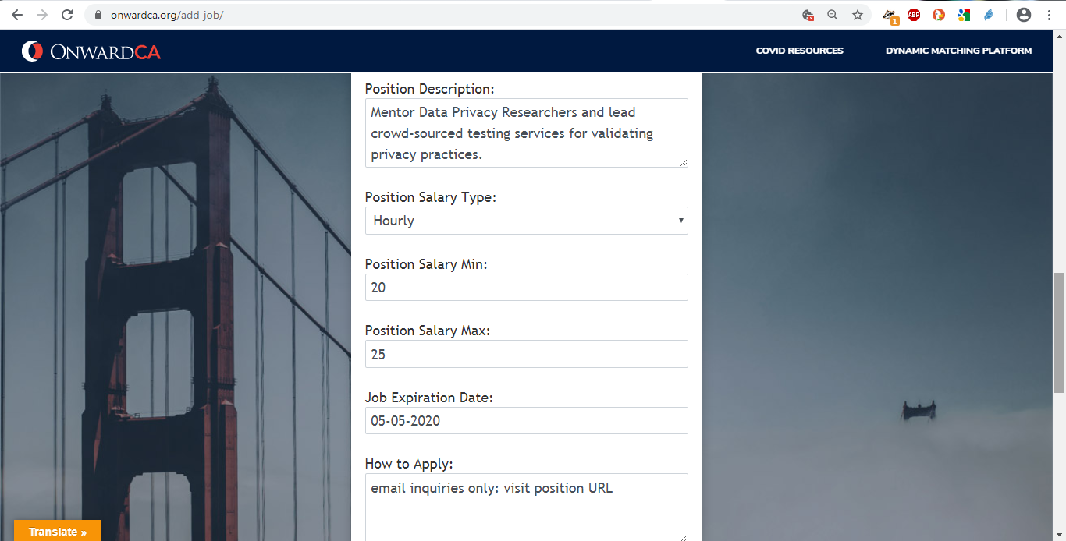
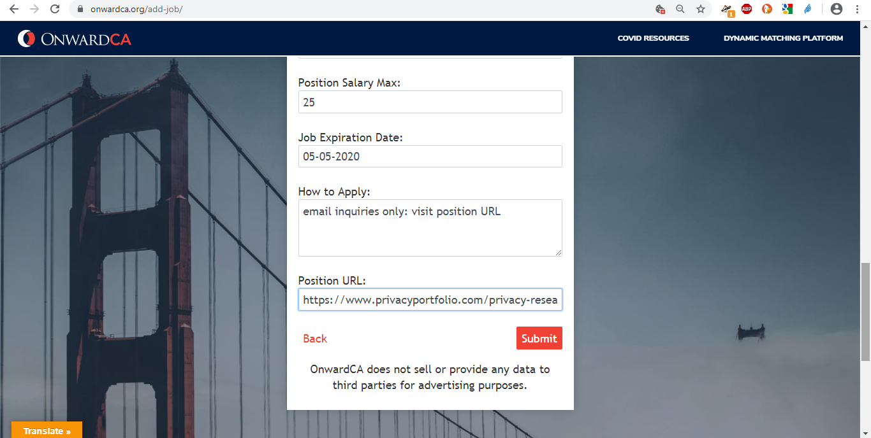

[ It’s a good thing that OnwardCA claims it does not sell or provide any data to third parties for advertising purposes. However, OnwardCA does not explicitly provide transparent notice of what purpose your data is used for.
Is it fair to assume: if no person is ever notified of a match with any resource or job opportunity, because OnwardCA obtained the listing data illegally or was used for purposes prohibited under the terms of Salesforce’s Community Licenses with or without Salesforce’s permission, that we don’t know and therefore cannot trust what consumers’ personal data is being used for? ]

[ This screenshot documents the parameters used to filter resources or jobs listings. ]
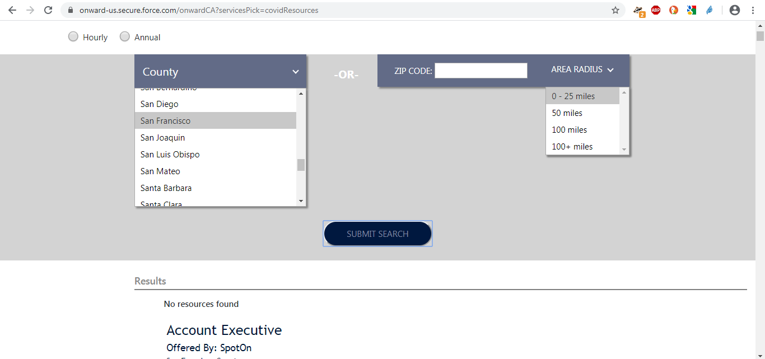

[ This screenshot documents the process Salesforce uses to manage privacy requests and comments. This process is relevant because SFDC Community Licenses are not exempt from data privacy practices and laws: in other words, these licenses should not provide permission for anyone to list organizational entities on a website without their consent. ]
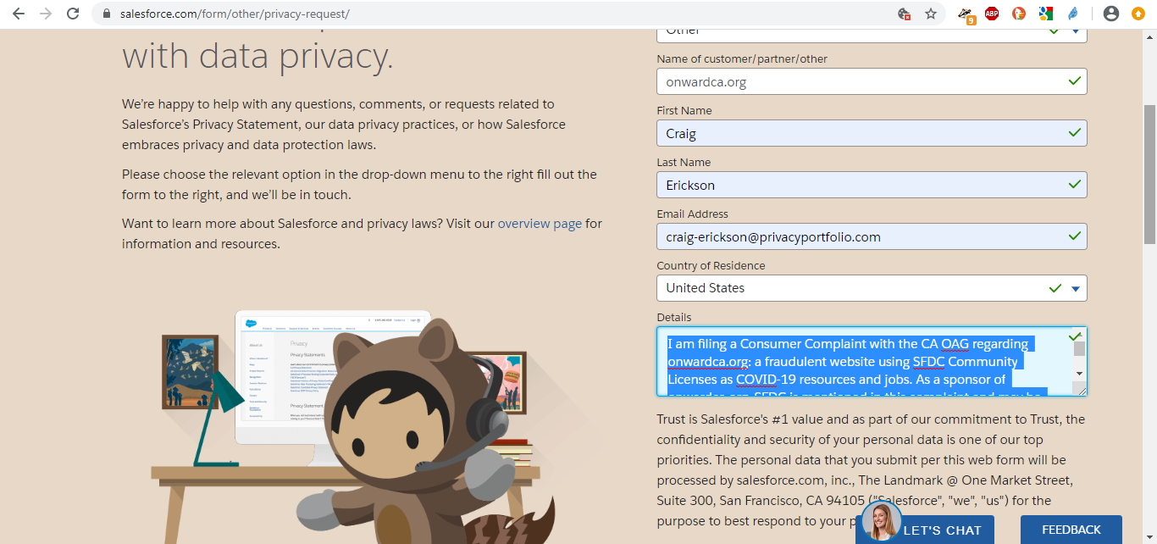

[This was submitted on April 14, 2020. As of 4/18/2020, no response has been received from Salesforce. The screenshot below documents that a separate email was sent directly to Salesforce, notifying them that a complaint was pending their response. ]
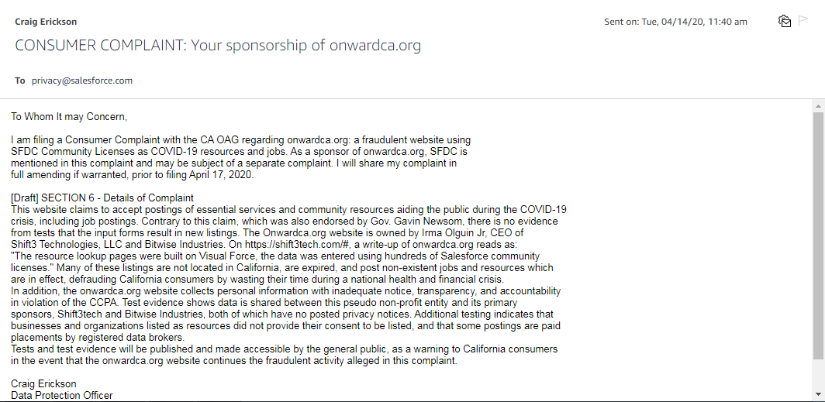

[ The following two screenshots document the email we sent to a sampling of organizations listed onwardca.org]
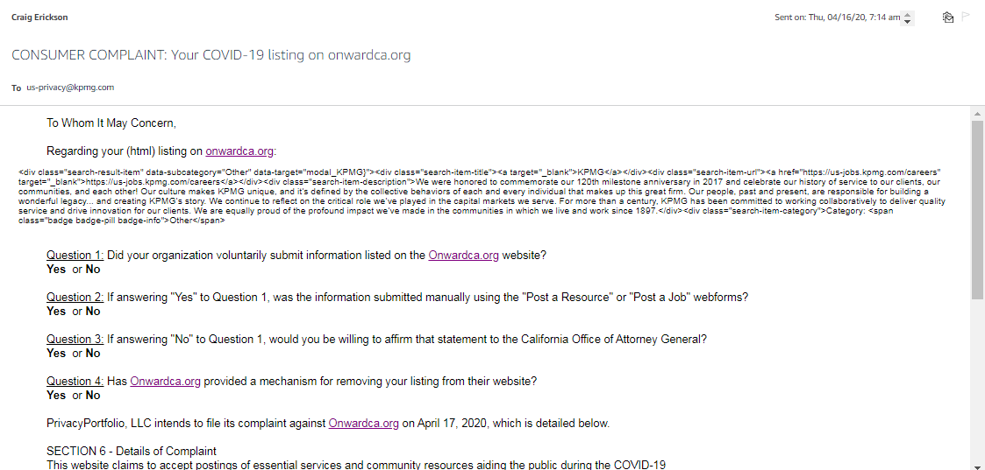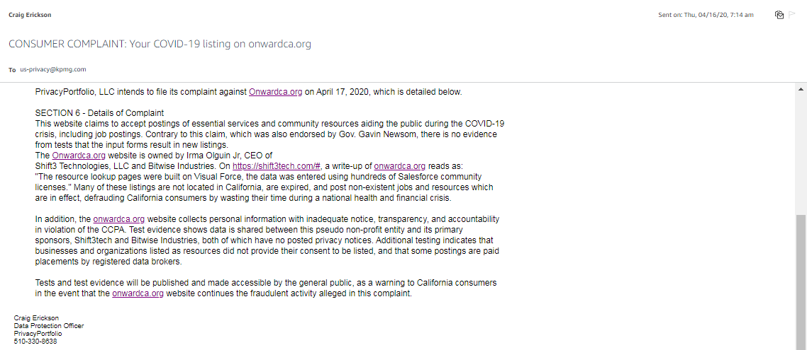

[ The following screenshots document the sample of organizations contacted to determine if permission to post was given to onwardca.org]
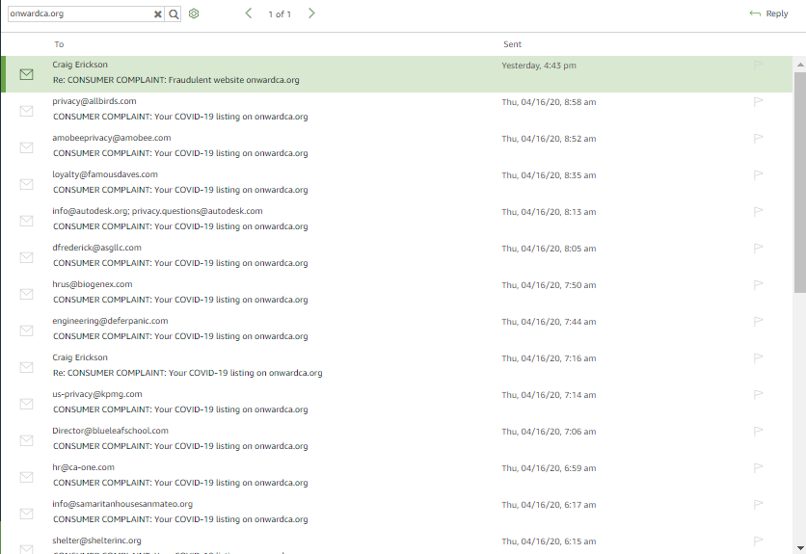
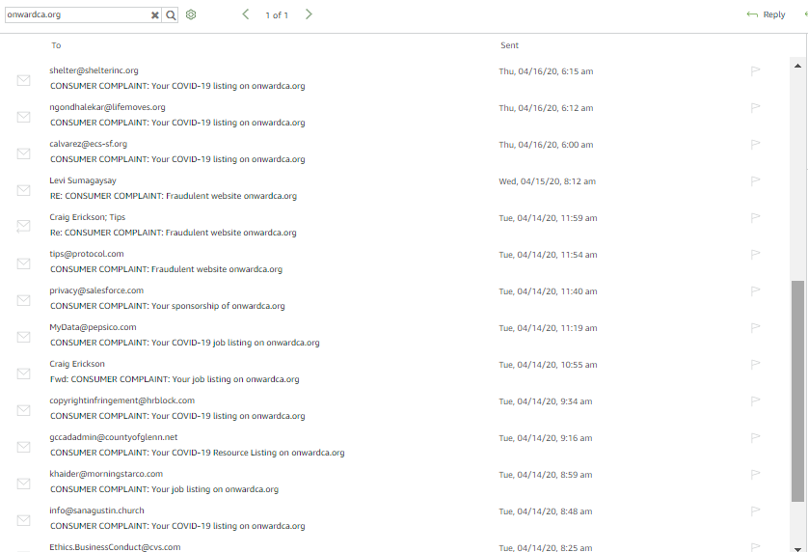
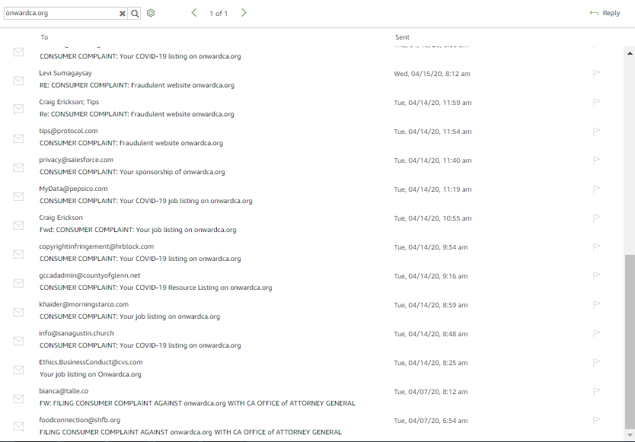
[ This is the end of evidence collected during this test iteration. PrivacyPortfolio encourages others to independently replicate this test or execute new tests, add their own evidence to the data catalogue and analyze the evidence we’ve published. ]

