On October 20-21, I attended SIGNAL 2021 and ended up conducting a mini-PIA. That wasn’t my intention, but as Army Rangers often say, “Never pass a problem”.
It all started when I asked the Concierge a question…
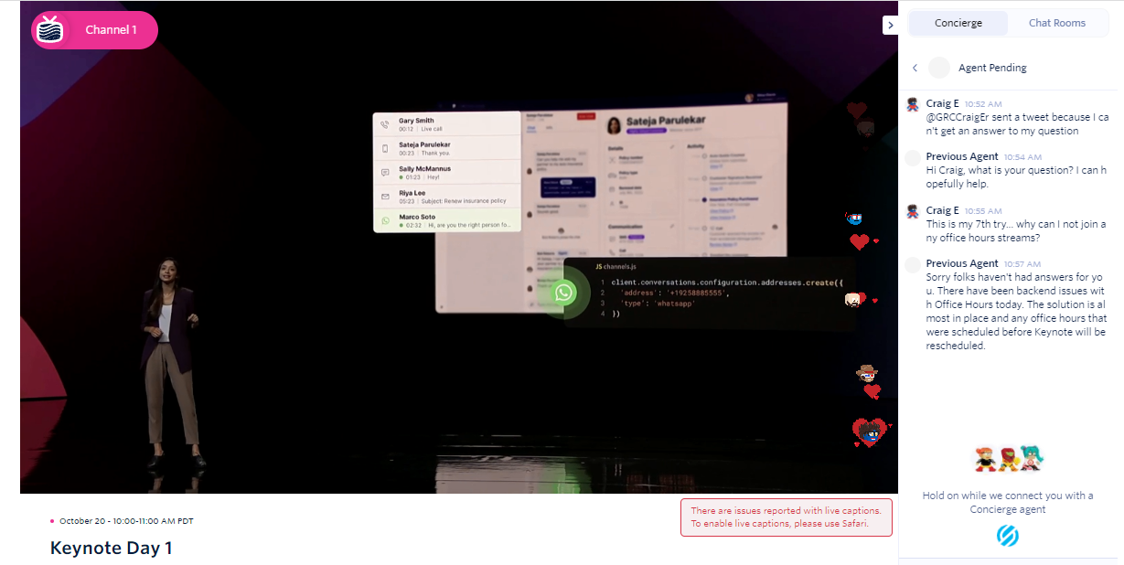
(As I learned later on, office hours are reserved for paid attendees, which is why I replied back via email)
On Fri, Oct 22, 2021 at 11:49 AM Craig Erickson <craig-erickson@privacyportfolio.com> wrote:
Thank you for putting on this event. I learned a great deal about the products, and cultural values at Twilio.

I was surprised that Office Hours were only accessible to paid attendees.
Do prospective customers fork out $200 to talk to your people? I don't think so.

One suggestion I have is around TRUST: Consider vetting your sponsors.
I consented to share my information with 20 sponsors and after analyzing every legal policy, and conducting scans of their sites,
I regretted my decision. I'm hoping they don't SMS me - that wasn't my intention.

I'm happy to share the results of my Vendor Risk tests with you, and I can also share the data privacy tests I've conducted on Twilio's practices over the past two years which you could use to directly validate my approach and findings.

Twilio is in a great position to lead by example when it comes to TRUST.
Having a requirement that sponsors actually HAVE a privacy policy, or better yet, a dated policy, would be a huge improvement.

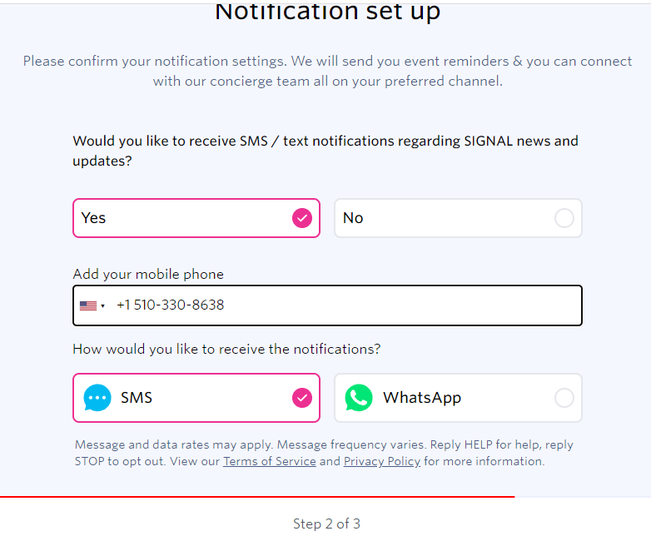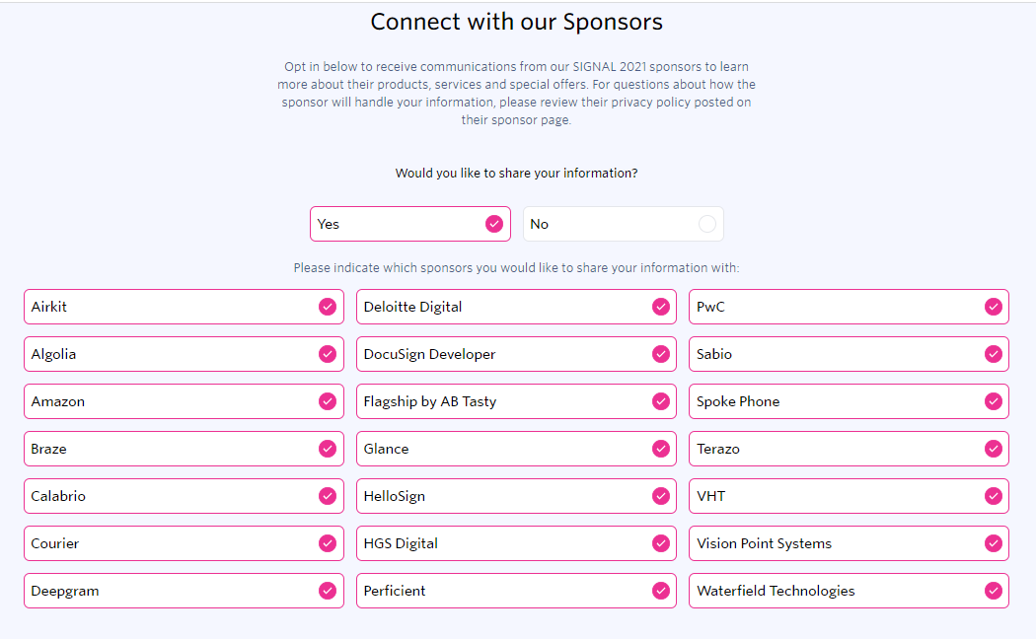The reason why I vetted the sponsors is because I hoped to hear from them, but did I consent to them sending me text messages via SMS? (Step 2 of 3, Step 3 of 3) When I checked my text messages on my Android phone I noticed that Twilio’s recruiters were sending me SMS messages that I did not consent to receive.
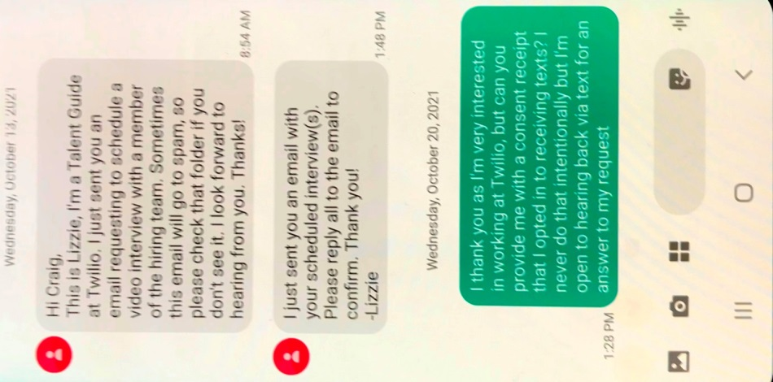
This tells me Twilio doesn’t have a consent management system or isn’t using it consistently in HR, and most likely in other areas… I’m still waiting for a response. I doubt many employers get requests like this from job candidates, worried they will get swept under the rug as a potential troublemaker – but I’ve learned not to underestimate people!

This is how DAY TWO started out for me:
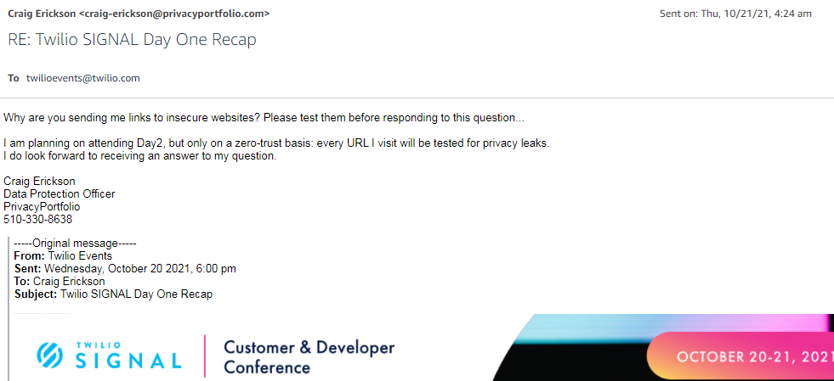
This is what happened when I clicked “Browse tomorrow’s sessions”:
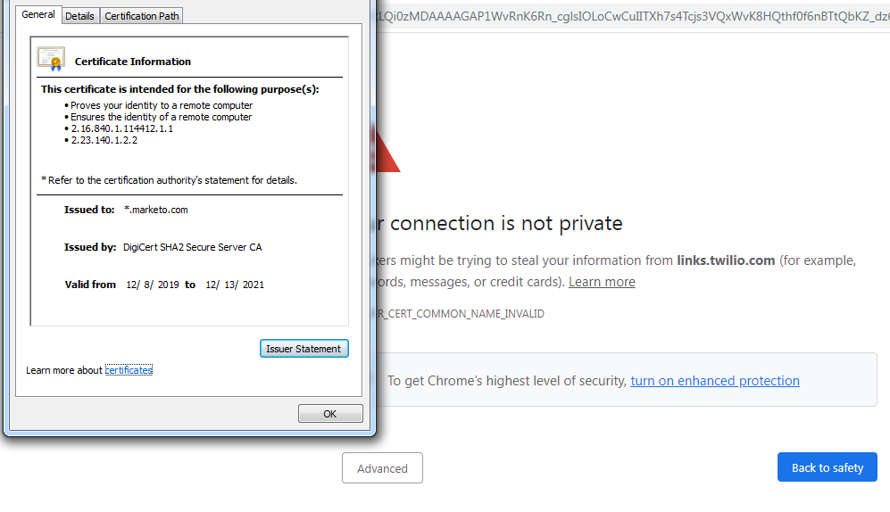
So I submitted a security incident report to support, but I knew my request would get tagged as “not a security incident” internally so I registered for a new Twilio account so I could submit it from there…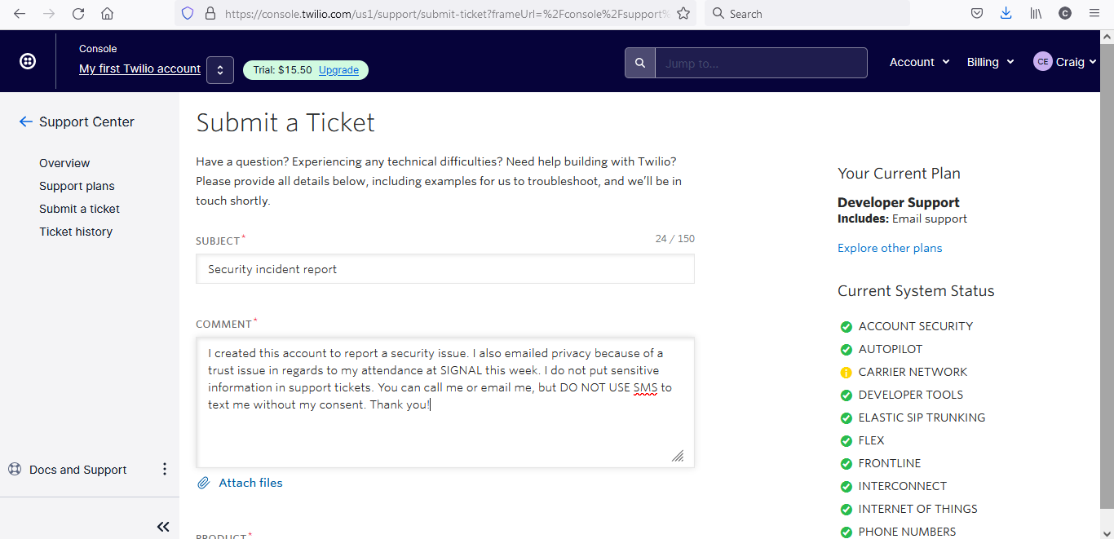
Ahoy Twilio!

Abigail was responding to this and needed more info.
Two issues:

#1: This email I received this morning:
SIGNAL Day 1: The 1st growth automation platform for the digital era
At the bottom I clicked, Browse tomorrow's sessions https://u3528416.ct.sendgrid.net/ls/click?upn=g9wRt9AavN88s36J1Koavx4fVLHITr3ytvjwLHAz9TYzOKgS-2Bjgi1RAF6jW1ympNWfZkESrHQCvN81yPvAtCMc7yu3RjHPZKJopDJk8YuOKyVTKo4vV-2F-2BpscBuSD1dM-2BRR6Z6x6bkmpML4K1cUB301cwca86a4B-2F5yojpq1upI4-3DYZy7_wh0zwefIQbXK82wQz9cAATSppm-2FEbIsQZht-2FdRxzoQZ6GMZNlU11S45TmCgLgR6Laev0x84vHwxzgezCq97sybgL2xuk-2FZCk3CSsC3Mepmuz-2B73z5cLs9KlPP08YOnDPIoUMr0nE2xatViEbo-2BbHDUHm0S-2F8W8M1bc0HzrlGUq0EZKIu2tR3Z01-2B7nnWVf4-2FrA1BdvmwULzXOuBEWQvs-2Bbos0zX8xfcSCv3zweybctx6RC2We7crINElsMPz4qNL

and I got this screen, (attached: twilio-signal-email.png)

#2 My consent for Twilio to text me via SMS:
(attached: twilio-signal-sms.png)
This is step 2 of 3 and it is unclear as to whether I have consented to give Sponsors permission to SMS me.
In Step 3, I choose to share my info:
(attached: twilio-signal-sms2.png)
My two questions are: am I giving consent for Sponsors to SMS me?
and, Can I revoke my consent? I've read all these Sponsors' privacy policies and scanned their websites for third-party trackers, and only two of them passed muster....

These aren't a huge priority but we're trying to build trust, and I appreciate Abigail reaching out to find what going on...

Craig Erickson
Data Protection Officer
PrivacyPortfolio
I used my typical Vendor Risk onboarding process to establish a baseline:
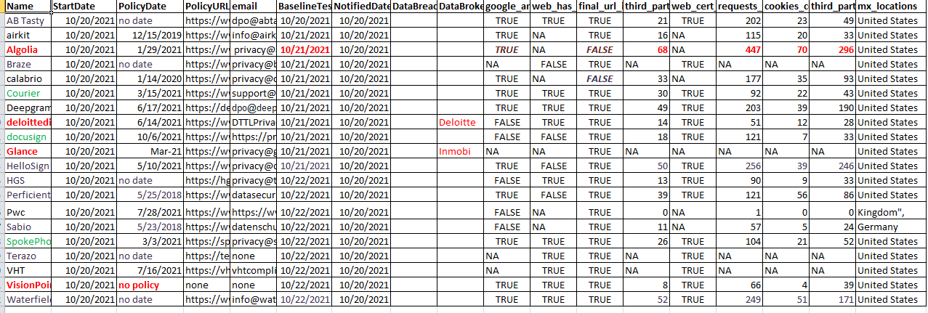
And generated this Infographic:
